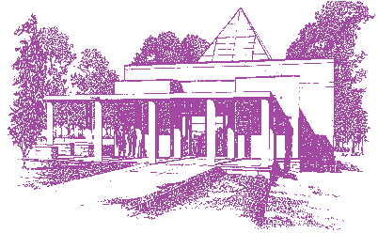
Ekoji Buddhist Temple
- The Temple of The Gift of Light -
6500 Lakehaven Lane, Fairfax Station, VA 22039
TEL: (703) 239-0500 Website: www.ekoji.org

Dear supporting partners and organizations,

We need your help in supporting our annual Obon Festival. This event will be held at Ekoji Buddhist Temple in Fairfax Station, VA on Saturday, July 13, 2024. Information is posted on our website, http://www.ekoji.org.

The Obon Festival is one of the most well-known and important cultural events in Japan where one takes the opportunity to honor and celebrate their ancestors. This engenders an awareness for how all those who have come before us have influenced our lives today. Our celebration is the only Obon Festival in the Washington DC metropolitan area. We had been holding this event every year since the early 1990’s until we paused due to the COVID-19 pandemic in 2020. Our crowds grew over the years, and we annually welcomed 800-1,000 visitors. We restarted this tradition in 2022 and welcomed 1000 visitors, and we look forward to celebrating with our visitors again this year.

Our festival is a cultural experience, featuring joyous aspects such as Japanese folk dancing, a taiko performance by Nen Daiko (http://nendaiko.org), Hawaiian music by the Aloha Boys (http://www.alohaboys.com), great food, vendors, temple tours, and more solemn aspects, such as lighting a candle in our Japanese garden in memory of one’s ancestors. Everyone is welcome to light a candle. It’s a perfect summer evening filled with unforgettable moments.

Sponsorship will be used to offset the costs of the festival and we would appreciate your help! Sponsors will have the option for their name/logo prominently featured on our festival webpage, printed materials, and on signage on festival grounds. Ekoji Buddhist Temple is a 501(c)(3) organization and we can provide a tax letter. Sponsorship levels include:

_____ $100 _____ $1,000
_____ $250 _____ more than $1,000
_____ $500 _____ some other amount

Please write checks out to Ekoji Buddhist Temple with “Obon Festival” on the memo line, and they may be mailed to the address in the letterhead above. Please contact us if you have any questions. We truly appreciate your time and consideration.

Sincerely,
The 2024 Obon Planning Committee
Email: ekoji.info@gmail.com

